Sheet Metal Countersink Forming
Project Number: A-116
Project Video
Summary
A leader in production of bullet-resistant and acoustical door frames required a machine that was able to form countersinks in sheet metal without compromising the strength of the interface with the fastener. AIM-Joraco designed and fabricated a system consisting of a customized 16-ton Hydro-Aire Series hydro-pneumatic press with an integrated 90° rotating cam mechanism and interchangeable tooling.
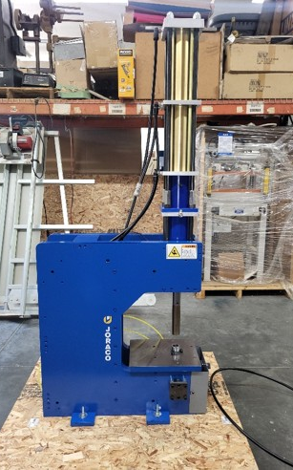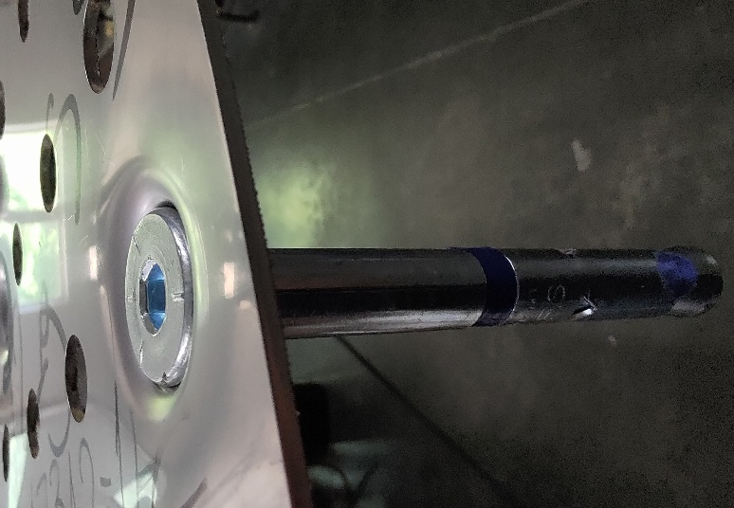
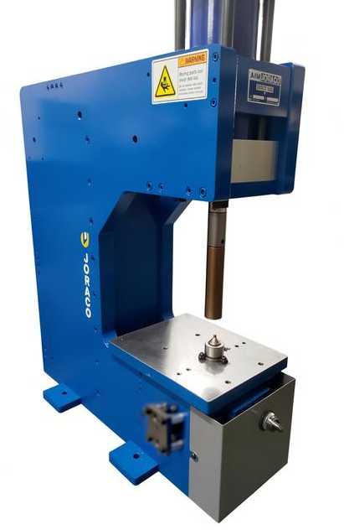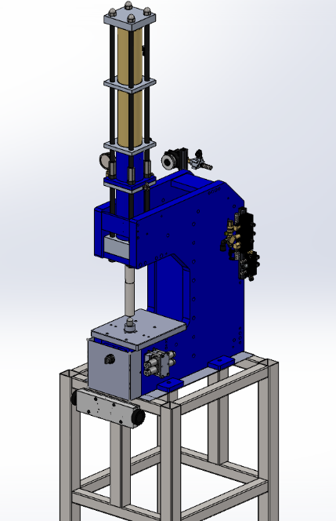

Customer Requirements
- Press throat depth must be 8” to accommodate product.
- Press must be able to form countersinks for fastener sizes from 3/16” to ¾”.
- Press must be able to form countersinks in stainless steel up to 12-gauge thick.
- Bottom forming tools must be able to raise and lower to leave a clear path when sliding material between pilot holes.

Design Challenges
- Expanded throat depth increases the bending load applied to the press frame.
- Incorporating motion transmission into the bottom tooling requires moving parts to withstand maximum press force.
- Hydro-Aire series exerts its force over a maximum ½” power stroke, which limits the countersink depth that can be formed by a single cycle of the press.

Process
- Stress simulations and iterative design were used to determine press frame dimensions that would withstand the 16 tons exerted by the press ram.
- Methods of motion transmission were evaluated for reliability and robustness, including additional stress analyses on components in the path of the press load.
- Designers capitalized on geometry and standardization in fasteners to design a system with minimal tooling changeout required.
- Material forming tests were run to establish limitations of countersink depth for various sheet metal thicknesses.
- Tests with various pilot hole sizes were performed so that designers could provide advice regarding forming process best practices.

Results
- A rotating cam was found to be the best method for moving and supporting the bottom forming tool under load.
- Countersink depth and diameter were controlled by hard stops of differing heights.
- The versatility of hard stops allowed end users to set the fastener head depth below flush as desired by fine-tuning the corresponding hard stop height.
- A separate pneumatic switch was included near the Synchro-Sig two-hand controller to allow the user to control the cam rotation with an intuitive interface.
- Hydro-Aire series press design allowed multiple material forming cycles to result in additional cumulative deformation, meaning that even countersinks deeper than ½” could be formed by cycling the press twice.

