Bushing Press Fitting
Project Number: A-136
Summary
A popular manufacturer of utility winches approached AIM-Joraco with a seemingly simple need: to press fit a bushing into a casting with a machine that would replace an arbor press. Beyond the pressing operation, the application became challenging due to its unique integration requirements including laser system measurements and integration with a customer-provided PLC. Using a Direct-Aire 400T press as a base, AIM-Joraco developed a solution that elevates the operator experience and facilitates QC.
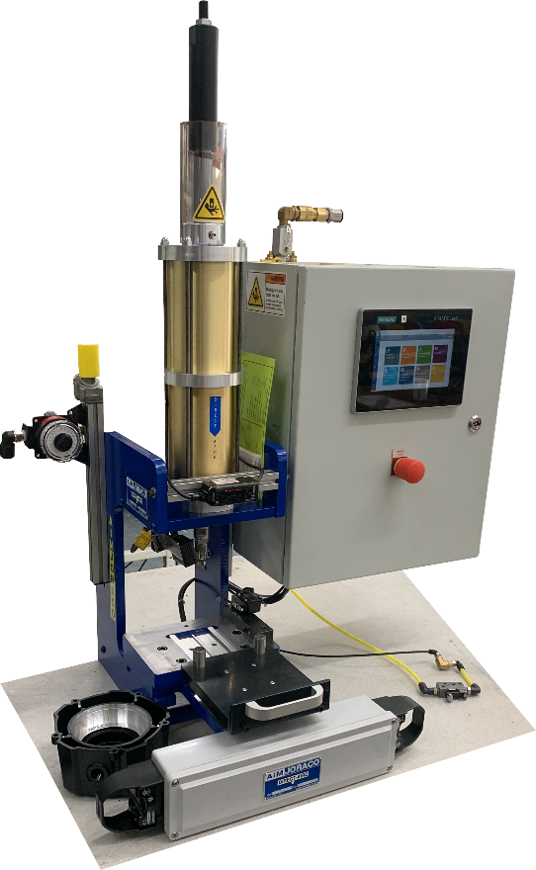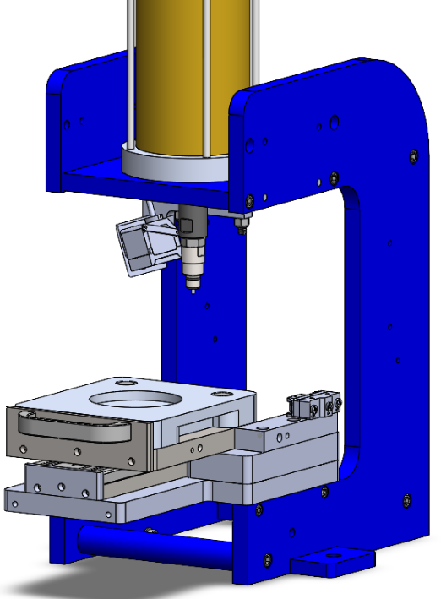
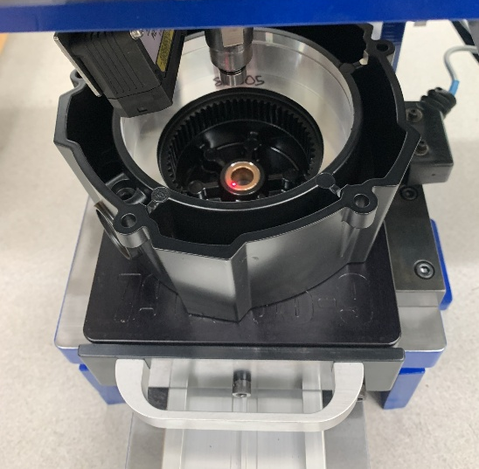
Customer Requirements
- Press must incorporate a means of identifying the quantity of washers inserted prior to pressing the bushing on top.
- Press must use a customer-specified PLC and HMI, while leaving the customer to develop the programming and safety logic.
- Press must include a manually actuated slide tray to facilitate loading parts.
- Slide tray must accommodate existing customer fixtures for part holding.
- The bushing must be able to be pushed onto and held by the ram-mounted press tool without falling into the casting.

Design Challenges
- Combining a slide track and a high-load press operation requires high dimensional precision.
- Press fitting a component that is initially attached around the tool results in a tight interface between the ram, bushing, and casting. Therefore, the casting must be held down so it does not stay attached to the ram after pressing.
- The casting geometry and the presence of the integrated position sensor limited the size of any hold-down components.

Process
- Designers conducted geometric analyses to establish location requirements so that position sensors could accurately detect the assembly stack up height and therefore effectively count components.
- Fabrication of certain components of the slide tray was finalized only after preliminary assembly so that component dimensions were based on as-built alignment of the slide carriage and surrounding supports.
- In keeping with the customer’s existing procedure, the tool incorporated an o-ring for retaining the bushing prior to pressing. First article testing was used to inform the finalize the interface dimensions and forces imposed on the inside of the bushing.

Results
- A spring-loaded ejector pin was incorporated into the press tool to push the casting assembly off of the ram as the ram retracts.
- The delivered press included all inputs necessary to create a program which incorporated quality inspection into the pressing process.
- Including SPDT switch outputs in the SYNCHRO-SIG™ Series Two Hand, Optical Touch Controller functionality made the system compatible with future client-integrated safety relays.
- The position sensor was successfully integrated to give accurate height measurements before and after addition of the bushing.

